# Creating and Subscribing - SNS Topics, Adding SNS event for S3 bucket

## Tasks

### Create SNS Topic

### Subscribe to SNS Topic

### Confirmation for SNS Topic

### Create S3 a Bucket

### Update SNS Topic Access Policy

### Create S3 Event

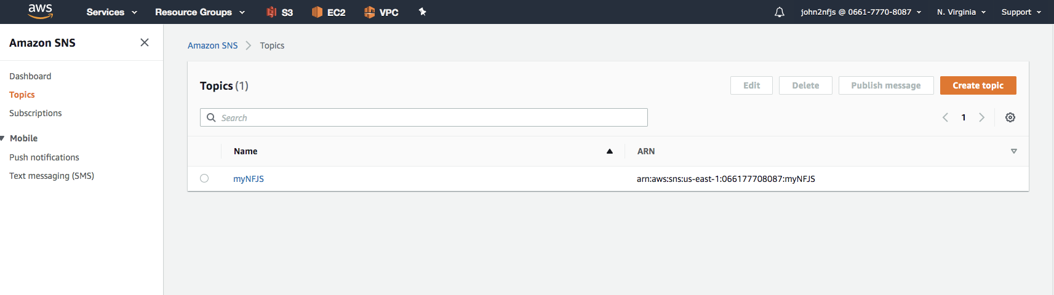

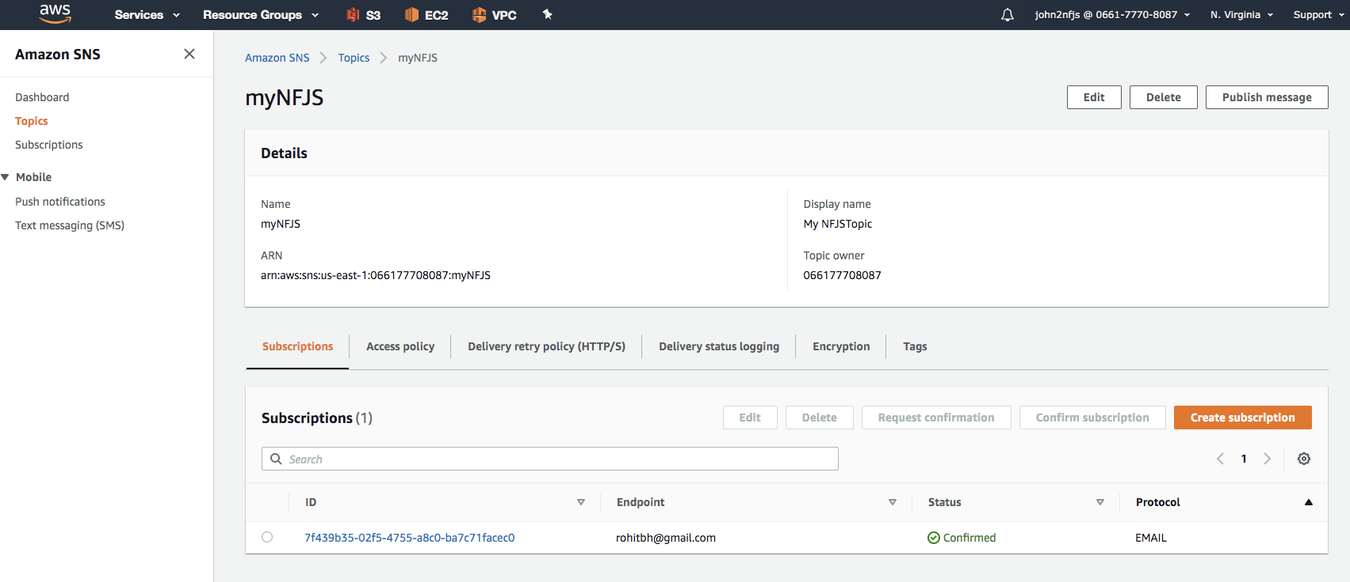

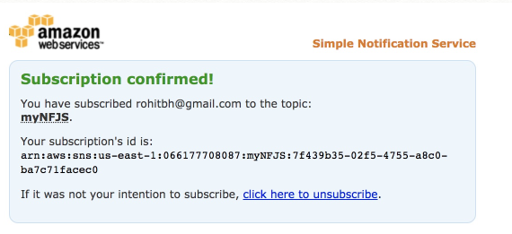

Access Policy

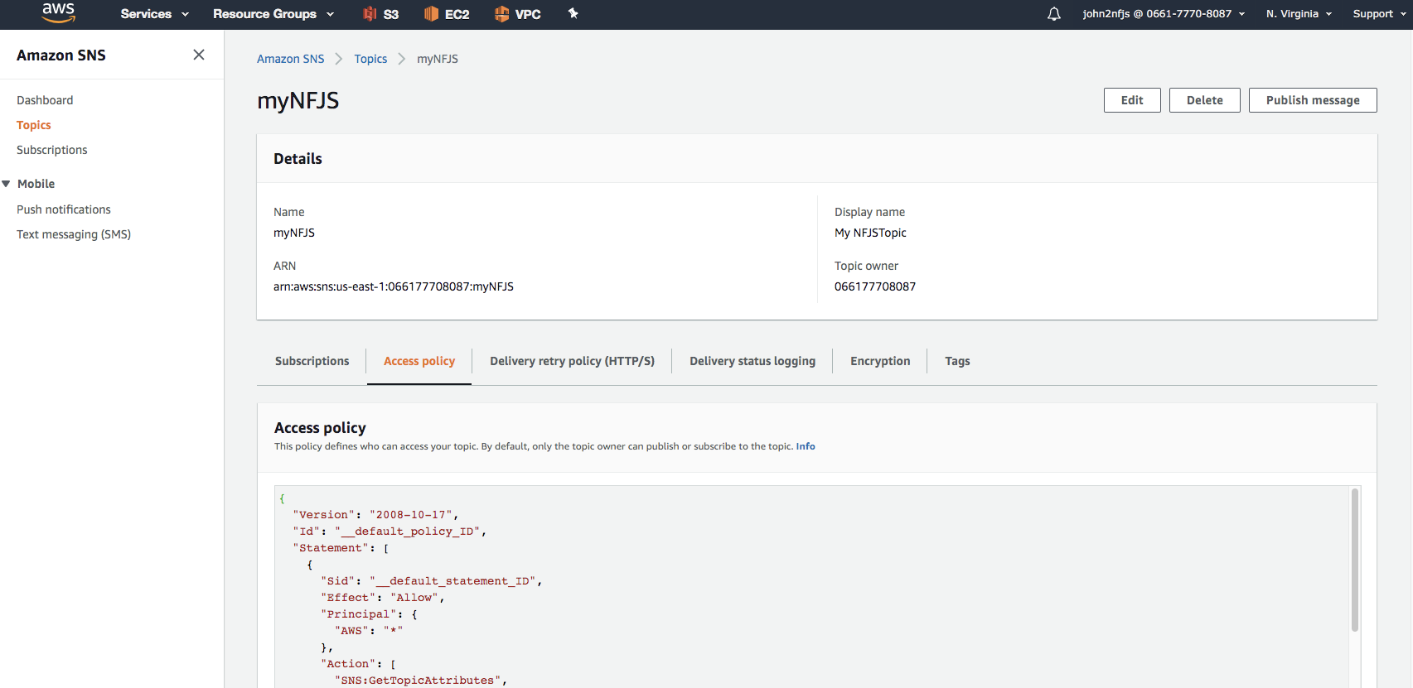

{

"Version": "2008-10-17",

"Id": "__default_policy_ID",

"Statement": [

{

"Sid": "__default_statement_ID",

"Effect": "Allow",

"Principal": {

"AWS": "*"

},

"Action": [

"SNS:GetTopicAttributes",

"SNS:SetTopicAttributes",

"SNS:AddPermission",

"SNS:RemovePermission",

"SNS:DeleteTopic",

"SNS:Subscribe",

"SNS:ListSubscriptionsByTopic",

"SNS:Publish",

"SNS:Receive"

],

"Resource": "arn:aws:sns:us-east-1:066177708087:myNFJS",

"Condition": {

"ArnLike": {

"aws:SourceArn": "arn:aws:s3:*:*:nfjsbucketsnstest"

}

}

}

]

}

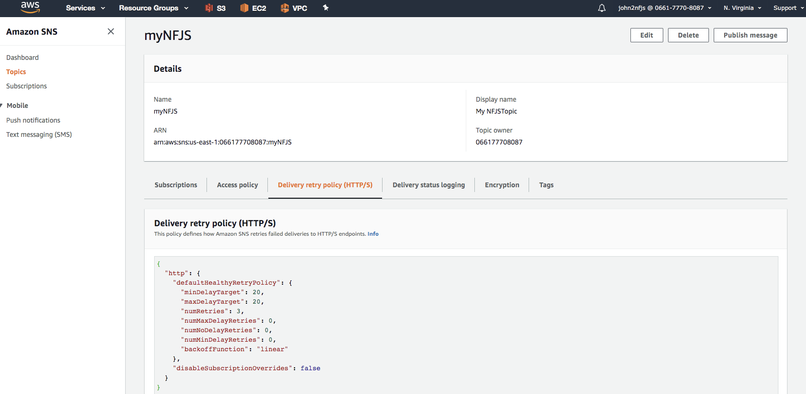

S3 Bucket

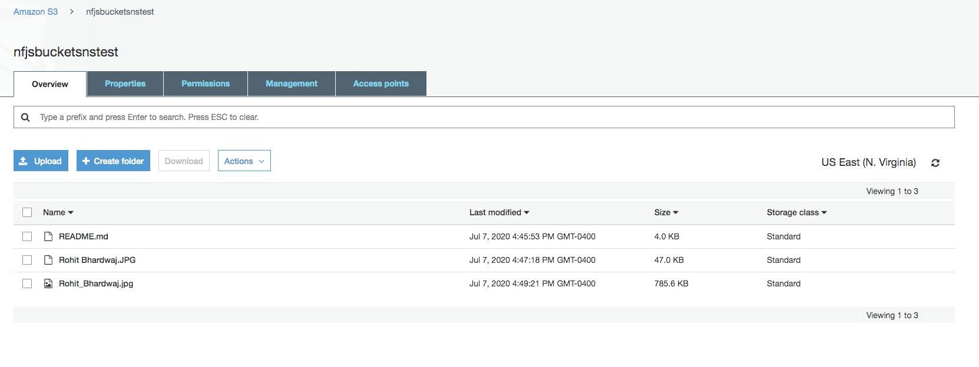

Properties

